Design and Verification of a 4-Bit RISC CPU Datapath in Verilog HDL
Project Report
Date: October 2026

Abstract
This report describes the design, implementation and verification of a small 4-bit RISC-style CPU written in Verilog HDL and simulated in Xilinx Vivado. The CPU has a 4-bit datapath, 12-bit instructions, four general-purpose registers, a 16 x 12 instruction ROM and a 16 x 4 data RAM. It supports arithmetic, logic, data-movement, memory and jump instructions. The design is organised as nine modules connected by a top-level module, driven by a hardwired control unit. A self-checking testbench runs a demonstration program and verifies the result of every important instruction; all 17 checks pass.

1. Introduction
A CPU repeatedly fetches an instruction from memory, decodes it and executes it. It consists of two cooperating parts: the datapath, which stores and processes data (registers, ALU, memories, multiplexers), and the control unit, which reads each instruction and generates the control signals that steer the datapath.

1.1 Aim
To design and implement a functional 4-bit RISC CPU datapath in Verilog HDL and to verify its behaviour through simulation and a self-checking testbench.

1.2 Objectives
- Design a 4-bit ALU supporting arithmetic and bitwise operations.
- Implement a four-register general-purpose register file.
- Design the program counter, instruction memory, instruction register, data memory and write-back multiplexer.
- Develop a hardwired control unit that decodes instructions.
- Integrate all modules in a top-level CPU and run a test program.
- Verify the CPU with a self-checking testbench and waveforms.

1.3 Key Specifications
Parameter | Specification
Datapath width | 4 bits
Registers | R0 to R3, 4 bits each (2-bit register numbers)
Instruction width | 12 bits
Instruction memory | 16 words x 12 bits (ROM)
Data memory | 16 words x 4 bits (RAM)
Program counter | 4 bits (16 instruction addresses)
Flags | Zero (Z) and Carry (C)
Control | Hardwired (combinational decoder)
Memory organisation | Harvard (separate instruction and data memories)
Tools | Verilog HDL, Xilinx Vivado behavioural simulation

2. Background

2.1 Instruction Set Architecture and RISC
The Instruction Set Architecture (ISA) defines the instructions, their binary encoding, the registers and the addressing of memory. This CPU follows RISC principles: all instructions have the same length (12 bits), the format is regular so decoding is simple, and only LD and ST access data memory (a load/store architecture). It is a teaching CPU and is not compatible with any commercial ISA.

2.2 Harvard Architecture
Instructions are held in a ROM and data in a separate RAM, each with its own address and data lines. An instruction can therefore be fetched while data memory is being accessed, and a data store can never overwrite the program.

2.3 Combinational and Sequential Logic
The ALU, multiplexer, control unit and memory read paths are combinational: their outputs depend only on current inputs. The program counter, instruction register, flag register, register file and RAM write are sequential: they change only on the clock edge. Reading the register file and RAM is combinational, while writing is clocked.

2.4 Two's Complement and Flags
A 4-bit value represents 0 to 15 unsigned, or -8 to +7 in two's complement. Subtraction is performed as addition of the complement. The CPU keeps two condition flags: Zero (Z), set when the ALU result is 0000, and Carry (C), produced by the ALU. The flags are stored in a flag register so that later instructions (JZ, JC) can test them.

3. Architecture

3.1 Instruction Format
Every instruction is 12 bits wide and uses the same layout:
Bits | Field | Meaning
[11:8] | opcode | Operation (4 bits)
[7:6] | Rd | Destination register and first source
[5:4] | Rs | Second source register
[3:0] | imm4 | Immediate value, data-memory address or jump address
The CPU uses a two-address format (Rd = Rd op Rs), which leaves room for the 4-bit immediate in a 12-bit word. Example: ADD R1, R2 = 0000 01 10 0000 = 0x060.

3.2 Instruction Set
Opcode | Mnemonic | Operation | Flags updated
0000 | ADD Rd, Rs | Rd <- Rd + Rs | Z, C
0001 | SUB Rd, Rs | Rd <- Rd - Rs | Z, C
0010 | AND Rd, Rs | Rd <- Rd AND Rs | Z, C
0011 | OR Rd, Rs | Rd <- Rd OR Rs | Z, C
0100 | XOR Rd, Rs | Rd <- Rd XOR Rs | Z, C
0101 | NOT Rd | Rd <- NOT Rd | Z, C
0110 | LDI Rd, imm | Rd <- imm | none
0111 | MOV Rd, Rs | Rd <- Rs | none
1000 | LD Rd, [addr] | Rd <- MEM[addr] | none
1001 | ST Rd, [addr] | MEM[addr] <- Rd | none
1010 | JMP addr | PC <- addr | none
1100 | JC addr | if C = 1 then PC <- addr | none
1111 | JZ addr | if Z = 1 then PC <- addr | none
1011, 1101, 1110 | (unused) | No operation | none

3.3 Module Overview
The top-level module cpu_top connects nine sub-modules:
Instance | Module | Function
PC_UNIT | program_counter | Holds the address of the instruction to fetch; loads PC + 1 or the jump address
IM_UNIT | instruction_memory | 16 x 12 ROM holding the program
IR_UNIT | instruction_register | Clocked register holding the fetched instruction
CU_UNIT | control_unit | Hardwired decoder producing all control signals
FR_UNIT | flag_register | Stores Z and C flags
RF_UNIT | register_file | Four 4-bit registers, two read ports, one write port
ALU_UNIT | alu | Arithmetic and logic operations, produces Z and C
MUX_UNIT | mux | 4-to-1 write-back multiplexer
DM_UNIT | data_memory | 16 x 4 RAM for LD and ST
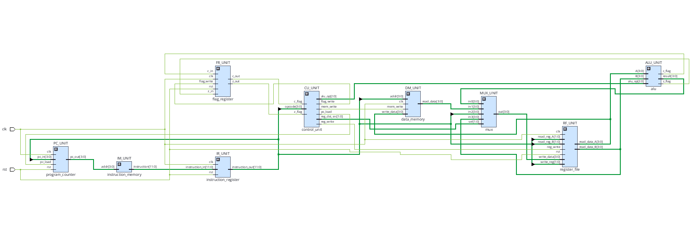
Figure 1. Module-level schematic of cpu_top generated by Vivado
Data flow: the PC addresses the ROM; the instruction is stored in the IR; its fields are split into opcode (to the control unit), Rd and Rs (to the register file) and imm4 (to the PC, the multiplexer and the data memory). The register file outputs feed the ALU; the write-back multiplexer selects what is written back to Rd. The ALU flags go to the flag register, and the stored flags return to the control unit for conditional jumps.

3.4 Write-Back Multiplexer
reg_dst_src | Selected source | Used by
00 | ALU result | ADD, SUB, AND, OR, XOR, NOT
01 | Data-memory read data | LD
10 | Immediate imm4 | LDI
11 | Rs register value | MOV

4. Control Unit Design
The control unit is purely combinational. All outputs are first set to a safe "do nothing" default, and a case statement on the opcode turns on only the signals the instruction needs. Unused opcodes therefore behave as NOP and no latches are created. Conditional jumps use the stored flags: JZ asserts pc_load only when Z = 1, and JC only when C = 1.
Instruction | reg_write | mem_write | pc_load | flag_write | reg_dst_src | alu_op
ADD | 1 | 0 | 0 | 1 | 00 | 000
SUB | 1 | 0 | 0 | 1 | 00 | 001
AND | 1 | 0 | 0 | 1 | 00 | 010
OR | 1 | 0 | 0 | 1 | 00 | 011
XOR | 1 | 0 | 0 | 1 | 00 | 100
NOT | 1 | 0 | 0 | 1 | 00 | 101
LDI | 1 | 0 | 0 | 0 | 10 | 000
MOV | 1 | 0 | 0 | 0 | 11 | 000
LD | 1 | 0 | 0 | 0 | 01 | 000
ST | 0 | 1 | 0 | 0 | 00 | 000
JMP | 0 | 0 | 1 | 0 | 00 | 000
JZ | 0 | 0 | Z | 0 | 00 | 000
JC | 0 | 0 | C | 0 | 00 | 000
NOP / unused | 0 | 0 | 0 | 0 | 00 | 000

5. Implementation
The design is written in plain Verilog-2005 with one module per file. The Vivado RTL schematic confirms how each module is synthesised:
- Program counter: an adder (PC + 1), a 2-to-1 multiplexer controlled by pc_load (PC + 1 or pc_in = imm4) and a 4-bit register with asynchronous reset.
- Instruction memory: inferred as a ROM addressed by the 4-bit PC.
- Instruction register: a 12-bit register that captures the ROM output every clock.
- Flag register: two flip-flops (Z and C) with a clock enable driven by flag_write.
- Control unit: small ROM-style lookup tables for alu_op, flag_write, mem_write, reg_dst_src and reg_write, plus a multiplexer that implements pc_load using the flags.
- Register file: four 4-bit registers with write-enable multiplexers and two read multiplexers (ports A and B). Port A reads Rd and port B reads Rs; the write address is Rd.
- Data memory: a 16 x 4 RAM with combinational read and clocked write when mem_write = 1. The address is imm4 and the write data is the Rd value.
- Write-back multiplexer: a 4-input, 4-bit multiplexer selected by reg_dst_src.
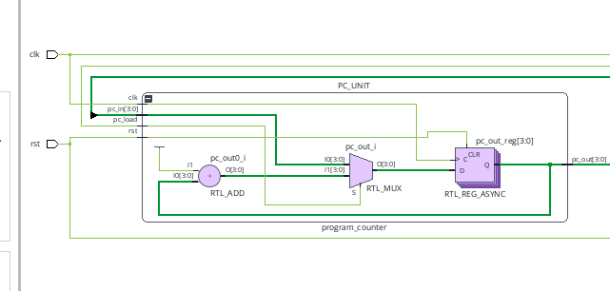
Figure 2. Inside PC_UNIT: adder, multiplexer and register.

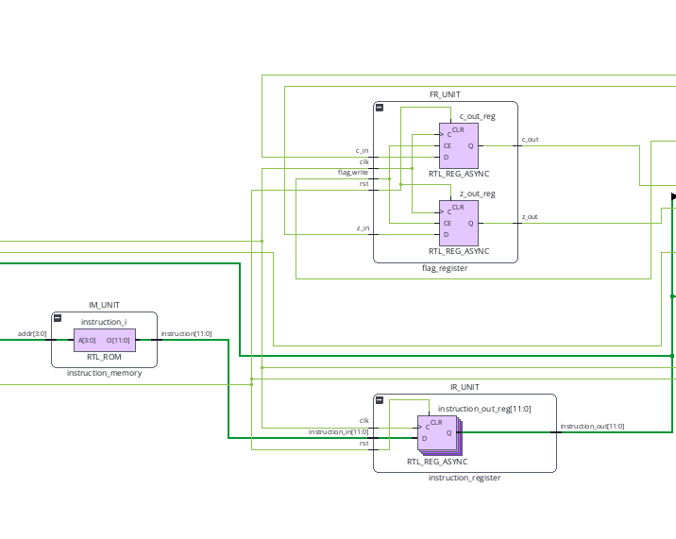
Figure 3. Inside FR_UNIT (flag register) and IM_UNIT / IR_UNIT
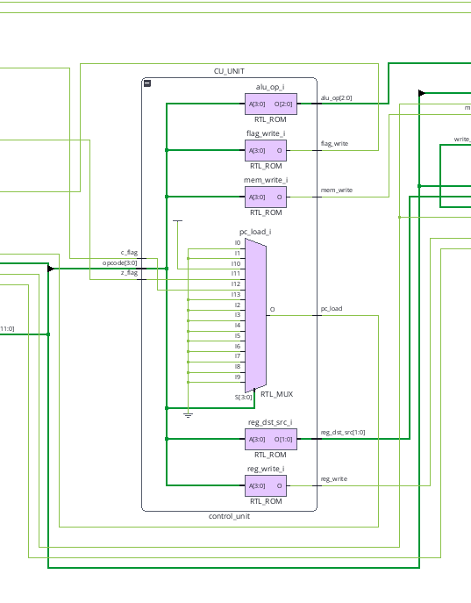
Figure 4. Inside CU_UNIT
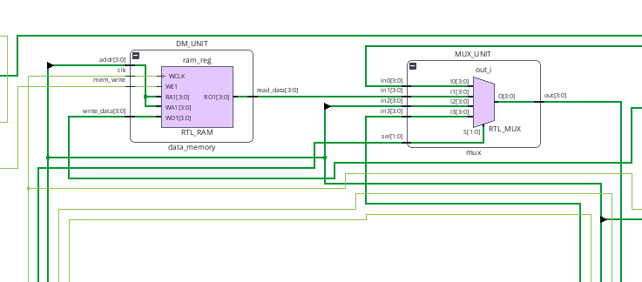
Figure 5. Inside DM_UNIT (data memory) and MUX_UNIT
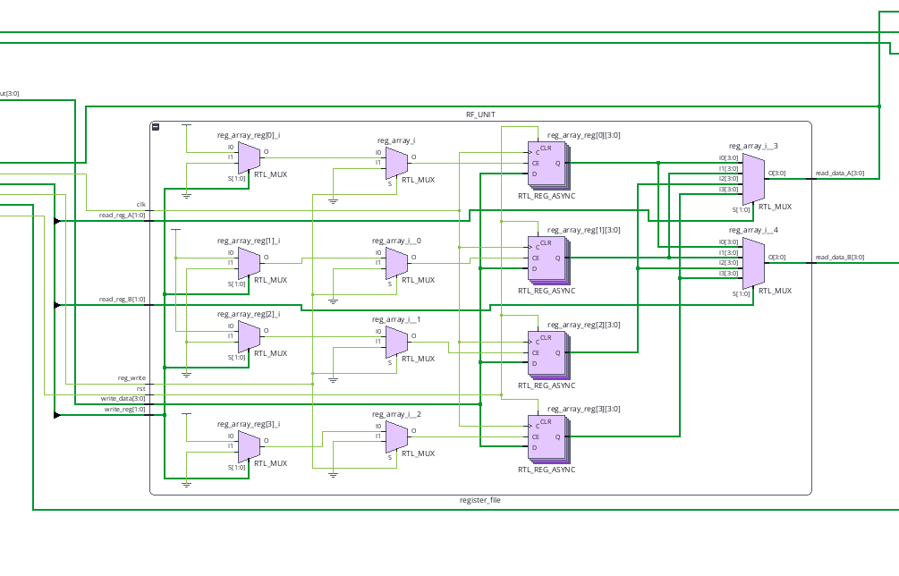
Figure 6. Inside RF_UNIT: four registers and two read multiplexers.

5.1 Instruction Timing
Because the instruction register is clocked, the CPU works as a two-stage pipeline: while one instruction is being executed from the IR, the next instruction is already being fetched from the ROM. One instruction completes per clock cycle.
A jump is decided when the jump instruction is in the IR, at which time the PC has already fetched the following instruction. That instruction is still loaded into the IR and executed, so the CPU has a one-instruction branch delay slot: the instruction immediately after a taken jump always executes. The demonstration program shows this at address 7. Programmers must place a harmless instruction (or a useful one) after each jump.

6. Test Program
The demonstration program is stored in the instruction ROM:
Addr | Hex | Instruction | Expected effect
0 | 645 | LDI R1, 5 | R1 = 5
1 | 683 | LDI R2, 3 | R2 = 3
2 | 060 | ADD R1, R2 | R1 = 8, Z = 0, C = 0
3 | 941 | ST R1, [1] | MEM[1] = 8
4 | 8C1 | LD R3, [1] | R3 = 8
5 | 170 | SUB R1, R3 | R1 = 0, Z = 1
6 | F08 | JZ 8 | Taken (Z = 1): PC becomes 8
7 | 60F | LDI R0, 15 | Delay slot: still executes, R0 = 15
8 | 580 | NOT R2 | R2 = 12 (NOT 0011 = 1100)
9 | A09 | JMP 9 | Halt loop
The program exercises immediate load, addition, the store/load path through data memory, subtraction with the Zero flag, a taken conditional jump, a bitwise operation and an unconditional jump.

7. Verification

7.1 Self-Checking Testbench
The testbench generates a 100 MHz clock (10 ns period), applies reset for 20 ns and then samples the PC, registers and flags just after chosen clock edges. Two tasks, check (4-bit values) and check_bit (flags), compare each value with its expected result, print PASS or FAIL and count errors. The hierarchical names (for example uut.RF_UNIT.reg_array[1]) are used for observation and work in simulation only. A $monitor statement also prints PC, IR, R1 to R3 and the flags at every change for the simulation log.

7.2 Results
Test | Time | Check | Expected | Result
Reset | 11 ns | PC, R1, R2, R3 | all 0 | PASS (4 checks)
PC increment | 25 ns | PC | 1 | PASS
LDI R1, 5 | 35 ns | R1 | 5 | PASS
LDI R2, 3 | 45 ns | R2 | 3 | PASS
ADD R1, R2 | 55 ns | R1, Z, C | 8, 0, 0 | PASS (3 checks)
ST / LD | 75 ns | R3 | 8 | PASS
SUB R1, R3 | 85 ns | R1, Z | 0, 1 | PASS (2 checks)
JZ 8 taken | 95 ns | PC | 8 | PASS
Delay slot LDI R0, 15 | 105 ns | R0 | 15 | PASS
NOT R2 | 115 ns | R2 | 12 | PASS
JMP 9 | 125 ns | PC | 9 | PASS
The testbench finishes with the message tb_cpu PASSED: 17 of 17 checks OK.
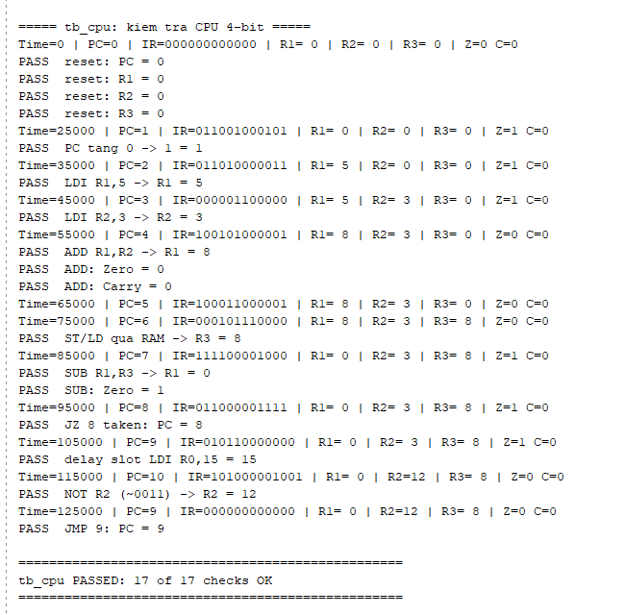
Figure 7. Vivado Tcl Console output of the self-checking testbench.

7.3 Waveform Analysis
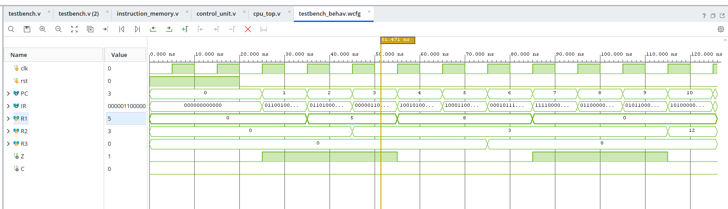,
Figure 8. Simulation waveform of clk, rst, PC, IR, R1, R2, R3, Z and C (0 to 125 ns).

The waveform agrees with the log:
- 0 to 20 ns: reset is active and the PC, IR and registers are 0.
- PC increments by one every clock (1, 2, 3, ... 7), jumps from 7 to 8 and then alternates between 9 and 10 in the halt loop.
- R1 changes 0, 5, 8, 0 (LDI, ADD, SUB).
- R2 changes 0, 3, 12 (LDI, NOT).
- R3 becomes 8 after the LD instruction.
- Z is 1 after the SUB result 0 and returns to 0 after NOT 3 gives a non-zero result. C stays 0 during the test.
Note on the Zero flag after reset: after reset the IR contains 000000000000, which decodes as ADD R0, R0. That instruction executes once and produces 0, so Z is 1 early in the run. This is a side effect of the all-zero reset value and does not affect the test results.

7.4 Observation on the Halt Loop
The unused ROM word at address 10 is 000 (ADD R0, R0). In the halt loop the delay-slot mechanism executes this instruction repeatedly. Since R0 = 15 at that time, the addition overflows and the Carry flag changes after about 125 ns. This does not change R1, R2 or R3, and the testbench stops before this point, but it shows why the delay slot must be considered when writing programs.

8. Limitations and Possible Extensions
Limitation | Cause | Possible extension
Delay slot after every jump | IR is clocked and there is no flush | Add a flush signal that loads a NOP into the IR when a jump is taken, or document the delay slot as an architectural feature
Reset value of IR is ADD R0, R0 | All-zero reset value | Reset the IR to an unused opcode (a NOP)
Only 16 instructions and 16 data words | 4-bit PC and 4-bit address field | Wider PC and address fields, or register-indirect addressing
No overflow or negative flag | Only Z and C implemented | Add V and N flags
No subroutines | No stack or link register | Add CALL / RET
Opcodes 1011, 1101, 1110 unused | Reserved | Add shifts, JNZ or HALT

9. Conclusion
A 4-bit RISC-style CPU was designed in Verilog HDL with a 12-bit instruction format, four registers, separate instruction and data memories, a hardwired control unit and a flag register supporting conditional jumps. The nine modules were integrated in cpu_top and simulated in Vivado. A self-checking testbench running a demonstration program verified reset, immediate loading, addition, subtraction, store/load through RAM, the Zero flag, a taken conditional jump, the branch delay slot, a bitwise NOT and an unconditional jump. All 17 checks passed, and the waveforms and the synthesised schematic agree with the intended design. The branch delay slot is the main architectural property to document, and it can be removed in future work by adding a pipeline flush.

